**Institute of Engineering & Technology**

**Devi Ahilya Vishwavidyalaya, Indore (M.P)**

**Department of Computer Science & Engineering**



**DATABASE MANAGEMENT SYSTEM(CER4C4)**

**Lab Assignment-3**

**Submitted To: Submitted By:**

**Mrs. Jyoti Haveliya Mam Tanishq Chauhan (21C4184)**

**CS-Dept CS “B” 2nd Year**

**IET-DAVV Enrollment No:- DE21622**

**Lab Assignment-3**

* **Create one table employee with fields**
* **Eno - primary key and apply sequence starts with 101**
* **Ename - not null**
* **Address - default 'Nashik'**
* **Joindate**
* **Post**
* **Salary - check > 5000**

**Query:-**

(I) CREATE TABLE employee

* (
* Eno int NOT NULL PRIMARY KEY AUTO_INCREMENT,
* Ename varchar(25) NOT NULL,
* Address varchar(25) DEFAULT ‘Nashik’,
* Joindate DATE,
* Post varchar(25),
* Salary int CHECK(Salary > 5000)
* );

(II) ALTER TABLE employee

* AUTO_INCREMENT = 101;

(III) DESC employee;

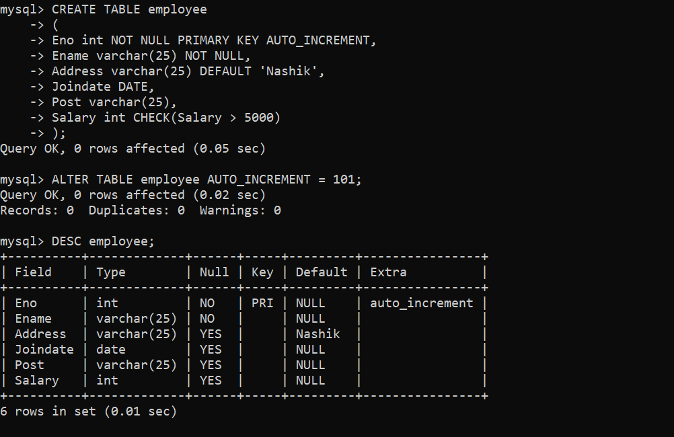

* **Create another table emp_proj with fields**
* **Eno - foreign key**
* **Project_name**
* **Loc**

**Query:-**

1. CREATE TABLE emp_proj

* (
* Eno int PRIMARY KEY,
* Project_name varchar(25),
* Loc varchar(25),
* FOREIGN KEY (Eno) REFERENCE employee(Eno)
* );

1. 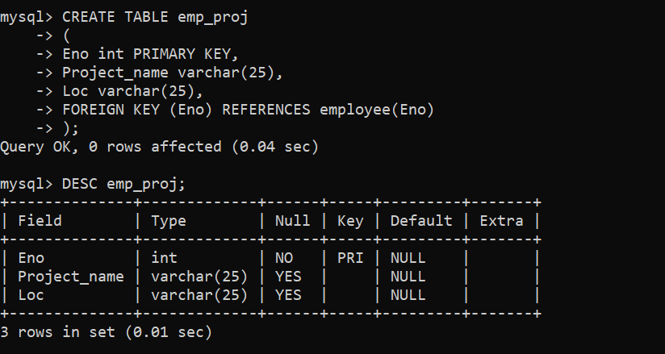DESC emp_proj;

* **Create Index on Ename field of employee table.**

**Query:-**

1. CREATE INDEX DEMOINDEX

* ON employee(Ename);

1. SHOW INDEXES FROM employee;
2. DESC employee;

